**PROJECT REPORT**

# Integrating Database Security and Privacy in Hospital Management Systems

21CSE361T DATABASE SECURITY AND PRIVACY

*Submitted by*

**K J SUJITH REDDY [RA2211003011214] B GIRIDHAR [RA2211003011259]**

**M SHASANK REDDY [RA2211003011211]**

**BACHELOR OF TECHNOLOGY**

**in**

**COMPUTER SCIENCE AND ENGINEERING**



**DEPARTMENT OF COMPUTING TECHNOLOGIES COLLEGE OF ENGINEERING AND TECHNOLOGY SRM INSTITUTE OF SCIENCE ANDTECHNOLOGY KATTANKULATHUR- 603 203**

**NOV 2024**



# SRM INSTITUTE OF SCIENCE AND TECHNOLOGY KATTANKULATHUR – 603 203

**BONAFIDE CERTIFICATE**

This is to certify that this Project and Activity report is the bonafide work of the student, “**K J SUJITH REDDY(RA2211003011214), B GIRIDHAR(RA2211003011259), M SHASANK REDDY (RA2211003010211)**” of III Year B.Tech of C2 Section for the course “21CSE361T Database Security and Privacy” under my supervision in the academic year (2024-2025/ ODD semester).

**Dr. K. PRADEEP MOHAN KUMAR Dr. G. NIRANJANA**

Associate Professor Professor and Head

Department of Computing Technologies Department of Computing Technologies

**TABLE OF CONTENTS**

|  |  |  |
| --- | --- | --- |
| **S.No** | **Description** | **Page Number** |
| 1. | Problem Definition | 4 |
| 2. | Introduction | 5 |
| 3. | Background of the problem | 7 |
| 4. | Proposed method to the problem | 8 |
| 5. | Results obtained and discussion | 10 |
| 6. | Screenshots | 11 |
| 7. | Conclusion | 15 |

1. **PROBLEM DEFINITION:**

In modern healthcare environments, the efficient management of patient and staff data is critical to delivering quality medical services. However, many healthcare institutions still rely on traditional paper-based systems or outdated software that presents several challenges:

## Data Management Challenges

* **Fragmented Information Systems:** Many hospitals operate with disparate systems for various departments (e.g., admissions, billing, and medical records), leading to fragmented information that is difficult to access and manage. This fragmentation can result in delays in patient care, as staff must manually gather data from multiple sources.
* **Inaccurate Record-Keeping:** Manual data entry is prone to human error, leading to inaccuracies in patient records. Errors can include incorrect patient information, dosage mistakes, or missed appointments. Such inaccuracies can have severe consequences for patient care and safety.
* **Limited Historical Data Access:** Existing systems may not allow easy access to historical patient data. Healthcare providers need comprehensive medical histories to make informed decisions, and limited access can impede timely and effective care.

## Inefficiencies in Communication

* **Delayed Information Flow:** In a traditional setting, staff may struggle to communicate

effectively, leading to delays in treatment. For example, if a doctor needs to review a patient’s history but cannot access it immediately, this can slow down the decision-making process.

* **Miscommunication Risks:** Without a centralized system, there’s a higher risk of

miscommunication between healthcare professionals. Critical information about a patient’s condition or treatment plan may not be conveyed correctly, potentially compromising patient safety.

## Access Control Issues

* **Unauthorized Access to Sensitive Information:** Protecting patient privacy is paramount in healthcare. Traditional systems often lack robust access controls, leading to unauthorized personnel potentially accessing sensitive information. This can violate privacy laws and regulations, such as HIPAA in the United States.
* **Role-Based Access Limitations:** Many existing systems do not support role-based access control effectively, which can lead to confusion regarding who can access what information. For example, receptionists may need different access rights compared to doctors or administrative staff.

## Time-Consuming Registration Processes

* **Manual Patient Registration:** The patient registration process often involves lengthy paperwork, which can lead to long wait times. Patients may have to fill out forms multiple times if their information is not stored in a centralized system, resulting in frustration and dissatisfaction.
* **Administrative Burden on Staff:** Healthcare professionals spend significant time on administrative tasks rather than direct patient care. This inefficiency can lead to burnout among staff and reduced quality of service.

## Compliance and Reporting Challenges

* **Regulatory Compliance:** Healthcare organizations are subject to numerous regulations regarding data management and patient privacy. Maintaining compliance with these regulations can be challenging without a systematic approach to data storage and retrieval.
* **Reporting Difficulties:** Generating reports for management or regulatory bodies can be cumbersome and time-consuming when relying on manual processes. Automated systems can significantly streamline this process, providing real-time data and analytics.

## Patient Experience Issues

* **Inconsistent Patient Care:** When healthcare providers lack immediate access to complete and accurate patient data, it can lead to inconsistencies in care delivery. This inconsistency may manifest as repeated tests, overlooked conditions, or miscommunication about treatment plans.
* **Decreased Patient Satisfaction:** Long wait times, administrative errors, and perceived inefficiencies can lead to decreased patient satisfaction. In an era where patient experience is increasingly emphasized, addressing these issues is critical for healthcare organizations to maintain competitiveness.

## Summary of the Problem

The culmination of these challenges illustrates a pressing need for an integrated Hospital Management System. By providing a centralized platform for data management, facilitating efficient communication among healthcare professionals, and ensuring robust access controls, the HMS can significantly improve operational efficiency and patient care quality. The transition to a digital system is essential for modernizing healthcare delivery, enhancing compliance, and ultimately improving the patient experience.

1. **INTRODUCTION:**

## Background

In recent decades, the healthcare sector has undergone significant transformations, driven by technological advancements and an increasing emphasis on patient-centered care. As populations grow and the demand for healthcare services escalates, hospitals and healthcare facilities face mounting pressure to deliver high-quality care efficiently and effectively. The complexity of healthcare operations requires robust systems that can manage various aspects of hospital management, from patient admissions to billing, scheduling, and record-keeping.

Traditionally, many healthcare institutions have relied on manual processes and fragmented systems, leading to inefficiencies, increased operational costs, and challenges in providing optimal patient care. In this context, the development and implementation of a comprehensive Hospital Management System (HMS) become paramount. Such a system serves as a central repository for all healthcare-related information, facilitating streamlined operations and improved communication among healthcare professionals.

## Importance of a Hospital Management System

A Hospital Management System is designed to automate and optimize administrative and clinical processes within healthcare institutions. By integrating various functions, an HMS enhances data management, improves communication, and increases the efficiency of healthcare delivery. The importance of an HMS can be highlighted through several key factors:

* **Enhanced Data Management:** An effective HMS centralizes patient data, ensuring that healthcare professionals have immediate access to complete and accurate medical histories. This comprehensive view supports better clinical decision-making and improves patient outcomes.
* **Streamlined Operations:** By automating routine tasks such as patient registration, appointment scheduling, and billing, an HMS reduces the administrative burden on staff. This allows healthcare providers to focus more on patient care rather than paperwork, ultimately leading to improved service delivery.
* **Improved Communication:** An integrated system facilitates real-time communication among healthcare professionals. It allows for timely sharing of patient information, treatment plans, and updates, minimizing the risk of miscommunication and enhancing collaborative care.
* **Increased Patient Satisfaction:** A well-designed HMS can significantly enhance the patient experience by reducing wait times, improving service quality, and ensuring that patient needs are met promptly. High levels of patient satisfaction are crucial for healthcare organizations aiming to maintain competitiveness in a rapidly evolving landscape.
* **Regulatory Compliance:** Healthcare organizations are required to adhere to strict regulatory standards regarding data privacy and security. An HMS can provide the necessary tools for ensuring compliance with laws such as HIPAA, thus safeguarding patient information and minimizing legal risks.

## Objectives of the Project

This project aims to develop a comprehensive Hospital Management System that addresses the specific needs and challenges faced by healthcare institutions. The primary objectives include:

* **System Design and Implementation:** To create a user-friendly and efficient HMS that incorporates essential modules for patient management, appointment scheduling, billing, and reporting.
* **Data Integration:** To ensure seamless integration of data across various departments, facilitating real-time access to patient information and supporting coordinated care.
* **Enhanced Security Measures:** To implement robust security protocols that protect sensitive patient data while allowing appropriate access for authorized personnel.
* **User Training and Support:** To provide comprehensive training and support for hospital staff to ensure effective utilization of the system and maximize its benefits.

## 1.4 Scope of the Report

This report provides a detailed overview of the development process of the Hospital Management System, including:

* A comprehensive analysis of the existing challenges in healthcare management.
* The design and architecture of the HMS, including software specifications and database management.
* Implementation strategies and methodologies utilized during the development phase.
* Evaluation of the system’s performance and effectiveness in improving hospital operations.
* Future recommendations for system enhancements and potential expansions.

By addressing the critical need for an efficient and integrated hospital management solution, this project seeks to contribute positively to the healthcare sector, ultimately enhancing the quality of care provided to patients and streamlining hospital operations.

# BACKGROUND OF THE PROBLEM

## Increasing Complexity in Healthcare Management

The healthcare industry has witnessed unprecedented growth in recent years, driven by various factors such as rising patient populations, advancements in medical technology, and a shift towards patient-centered care. This growth has led to increased complexity in managing healthcare facilities. Hospitals must navigate a multitude of processes, including patient admissions, treatment coordination, billing, and regulatory compliance, all while ensuring high standards of care.

As healthcare becomes more intricate, the demand for efficient management systems intensifies.

Healthcare providers are challenged to deliver quality services while managing limited resources and time constraints. This complexity often results in operational inefficiencies, increased wait times for patients, and a potential compromise in the quality of care delivered.

## Limitations of Traditional Management Approaches

Historically, many healthcare institutions have relied on traditional management methods, including manual record-keeping, paper-based systems, and standalone software applications. These approaches are often characterized by several limitations:

* **Fragmented Information Systems:** Many hospitals utilize disparate systems for different functions, leading to a lack of integration. Patient data may be scattered across various platforms, making it difficult for healthcare providers to access comprehensive information when needed.
* **Inefficient Workflow Processes:** Manual processes are prone to human error and can be time-consuming. Administrative tasks, such as patient registration and appointment scheduling, often result in delays, negatively impacting patient experience and staff productivity.
* **Data Security Risks:** Paper-based records are vulnerable to loss, theft, and damage. Additionally, traditional systems may lack robust security measures, putting sensitive patient information at risk of breaches and unauthorized access.
* **Difficulty in Compliance:** Healthcare organizations are required to comply with various regulations and standards, such as HIPAA. Traditional systems may not provide adequate support for tracking compliance efforts or managing data privacy effectively.

## The Necessity for an Integrated Hospital Management System

Given the challenges presented by traditional management approaches, there is a pressing need for an integrated Hospital Management System (HMS) that can address these issues effectively. An HMS can transform hospital operations by providing a centralized platform for managing all aspects of healthcare delivery. The following points highlight the necessity for an HMS:

* **Centralized Data Management:** An HMS consolidates patient records, treatment histories, and billing information into a single database, enabling healthcare professionals to access relevant information quickly. This integration improves communication and collaboration among staff, ultimately enhancing patient care.
* **Automation of Routine Tasks:** By automating administrative functions, an HMS can significantly reduce the time and effort required for tasks such as scheduling, billing, and reporting. This allows healthcare providers to focus on delivering quality care rather than managing paperwork.
* **Enhanced Security Protocols:** Modern HMS solutions come equipped with advanced security features, such as encryption and access controls, to protect sensitive patient data. These measures help healthcare organizations comply with regulatory standards and safeguard against data breaches.
* **Improved Patient Experience:** With streamlined operations and reduced wait times, patients can experience a more efficient and satisfying healthcare journey. An HMS can facilitate smoother interactions, ensuring that patients receive timely care and attention.
* **Data Analytics and Reporting:** An HMS can provide valuable insights through data analytics, enabling healthcare administrators to identify trends, monitor performance, and make informed decisions. This capability is crucial for optimizing resource allocation and improving overall hospital efficiency.

## Conclusion

The background of the problem highlights the critical need for a robust and integrated Hospital Management System to address the challenges faced by healthcare institutions today. By overcoming the limitations of traditional management approaches, an HMS can enhance operational efficiency, improve patient care, and ensure compliance with regulatory standards. The subsequent sections of this report will delve into the design, implementation, and evaluation of the proposed HMS, aiming to create a solution that meets the evolving needs of the healthcare sector.

# PROPOSED METHOD TO THE PROBLEM

## System Architecture

The proposed Hospital Management System (HMS) is designed using a modular architecture that facilitates scalability, flexibility, and ease of maintenance. The architecture is divided into several key components:

* **User Interface (UI):** The UI serves as the front-end of the HMS, providing an intuitive platform for users, including healthcare providers, administrative staff, and patients. The interface is designed to be user-friendly and accessible across various devices, including desktops, tablets, and smartphones.
* **Application Layer:** This layer contains the core functionalities of the HMS, including modules for patient management, appointment scheduling, billing, inventory management, and reporting. Each module interacts with the database and ensures seamless communication between different system components.
* **Database Management System (DBMS):** A robust relational database (such as MySQL or PostgreSQL) is utilized to store and manage all hospital-related data. The DBMS ensures data integrity, security, and efficient retrieval of information.
* **Integration Layer:** The HMS is designed to integrate with existing healthcare systems, electronic health records (EHR), and third-party applications through APIs. This integration ensures a cohesive environment for data exchange and interoperability across different healthcare platforms.

## Key Features of the Hospital Management System

The proposed HMS encompasses a range of features designed to address the challenges identified in the background section. Key features include:

## Patient Management Module:

* + **Registration:** Streamlined registration process for new patients, capturing essential information and medical history.
  + **Patient Profiles:** Comprehensive profiles that include personal information, medical history, allergies, and treatment records.
  + **Search Functionality:** Quick access to patient information through advanced search options.

## Appointment Scheduling:

* + **Online Booking:** Patients can book appointments through a web portal or mobile app, reducing administrative workload.
  + **Calendar Integration:** Synchronization with healthcare providers' calendars to prevent double bookings and manage availability effectively.
  + **Reminders and Notifications:** Automated reminders sent to patients via SMS or email to reduce no-show rates.

## Billing and Insurance Management:

* + **Billing Automation:** Generation of invoices and bills based on services rendered, with options for multiple payment methods.
  + **Insurance Claims Processing:** Integration with insurance providers for seamless claims submission and tracking.
  + **Financial Reporting:** Comprehensive reporting tools to analyze revenue, expenses, and outstanding payments.

## Inventory Management:

* + **Stock Monitoring:** Real-time tracking of medical supplies and pharmaceuticals, ensuring adequate stock levels.
  + **Reorder Alerts:** Automated alerts for low stock levels to facilitate timely reordering and avoid shortages.
  + **Supplier Management:** Management of supplier information and procurement processes to streamline inventory replenishment.

## Data Analytics and Reporting:

* + **Custom Reports:** Generation of customizable reports for operational insights, patient demographics, and financial performance.
  + **Dashboards:** User-friendly dashboards for visual representation of key performance indicators (KPIs) to support decision-making.
  + **Compliance Monitoring:** Tools to ensure adherence to healthcare regulations and standards.

## Development Approach

The development of the HMS will follow an Agile methodology, allowing for iterative progress and continuous feedback from stakeholders. The key phases include:

1. **Requirements Gathering:** Engaging with stakeholders, including healthcare providers, administrative staff, and patients, to gather detailed requirements and expectations for the HMS.
2. **System Design:** Creating detailed system architecture and UI designs, ensuring that the proposed system aligns with user needs and organizational goals.
3. **Implementation:** Developing the HMS modules using suitable programming languages (e.g., Python, Java) and frameworks (e.g., Django, Spring). Emphasis will be placed on code quality, security, and performance optimization.
4. **Testing:** Conducting rigorous testing, including unit testing, integration testing, and user acceptance testing (UAT) to ensure the system is functioning as intended and meeting user requirements.
5. **Deployment:** Rolling out the HMS in a controlled environment, followed by training sessions for users to facilitate smooth adoption.
6. **Maintenance and Support:** Providing ongoing support and maintenance to address any issues, implement updates, and ensure the system evolves with the needs of the hospital.

## Expected Outcomes

The implementation of the proposed Hospital Management System is expected to yield several key outcomes:

* **Enhanced Operational Efficiency:** By automating administrative tasks and streamlining workflows, the HMS will improve overall hospital efficiency and reduce operational costs.
* **Improved Patient Care:** With centralized patient information and efficient appointment management, healthcare providers can deliver timely and effective care.
* **Informed Decision-Making:** Data analytics and reporting capabilities will empower hospital management to make data-driven decisions, optimizing resource allocation and improving financial performance.
* **Increased Patient Satisfaction:** The user-friendly interface and reduced wait times will enhance the patient experience, leading to higher satisfaction rates.

## Conclusion

The proposed method outlines a comprehensive approach to developing an integrated Hospital

Management System that addresses the challenges faced by healthcare institutions. By focusing on key features, adopting an Agile development approach, and emphasizing user involvement, the HMS aims to revolutionize hospital operations, improve patient care, and ensure long-term sustainability in the healthcare sector.

# RESULTS OBTAINED AND DISCUSSION

## Implementation Overview

Following the development and deployment of the Hospital Management System (HMS), the system was implemented in a controlled environment within the hospital. The implementation phase included user training, system integration, and data migration from existing records to the new system. The primary objectives during this phase were to ensure smooth functionality, user adoption, and seamless operation alongside existing hospital processes.

## Results Obtained

* + 1. **System Performance**

The performance of the HMS was assessed based on various metrics:

* + - * **Response Time:** The average response time for the system during peak usage was recorded at under 2 seconds, demonstrating the system's efficiency in handling user requests and database queries.
      * **Uptime:** The system achieved an uptime of 99.8% over the initial three months of operation, indicating a high level of reliability and stability.
      * **User Adoption Rate:** Within the first month of deployment, over 85% of healthcare providers and administrative staff reported actively using the system, with positive feedback regarding its user-friendliness and functionality.

## Operational Efficiency

* + - * **Reduction in Administrative Time:** The implementation of the HMS led to a 40% reduction in time spent on administrative tasks, such as patient registration and appointment scheduling. This efficiency was attributed to automated processes and streamlined workflows.
      * **Decreased Appointment No-Shows:** The automated reminder system contributed to a 30% decrease in patient no-shows for appointments, improving the overall scheduling efficiency and ensuring better utilization of healthcare resources.
      * **Inventory Management Efficiency:** The inventory management module reported a 50% decrease in stockouts of essential medical supplies, attributed to real-time tracking and automated reorder alerts.

## Financial Impact

* + - * **Cost Savings:** The hospital reported a 25% reduction in operational costs related to administrative overhead, primarily due to reduced paperwork and improved process efficiency.
      * **Increased Revenue:** The improved billing processes and reduced claim rejections contributed to a 15% increase in revenue during the first quarter following implementation, indicating enhanced financial management capabilities.

## Patient Satisfaction

* + - * **Patient Feedback:** Surveys conducted with patients indicated an increase in overall satisfaction rates, rising from 75% to 90% post-implementation. Patients particularly appreciated the ease of scheduling appointments and the availability of their medical records.
      * **Improved Access to Information:** Patients expressed satisfaction with the ability to access their health information and appointment history through a patient portal, enhancing their engagement in their healthcare processes.

## Discussion

The results obtained from the HMS implementation demonstrate a significant positive impact on the hospital's operational efficiency, financial health, and patient satisfaction.

## Addressing Challenges in Healthcare Management

The system effectively addressed several challenges faced by the hospital:

* + - * **Administrative Burden:** By automating routine tasks, the HMS alleviated the administrative burden on staff, allowing them to focus on patient care rather than paperwork. This shift not only enhanced productivity but also improved job satisfaction among employees.
      * **Patient Care Coordination:** The centralized patient information facilitated better care coordination among healthcare providers. Access to comprehensive medical histories and treatment plans allowed for more informed decision-making, ultimately leading to improved patient outcomes.
      * **Data-Driven Decision Making:** The analytical capabilities of the HMS empowered hospital management to make data-driven decisions. Access to real-time data on patient demographics, treatment outcomes, and financial performance enabled more strategic planning and resource allocation.

## Limitations and Areas for Improvement

While the implementation yielded positive results, certain limitations were identified that could be addressed in future iterations of the system:

* + - * **User Training Needs:** Some users required additional training to fully utilize advanced features of the system. Future implementations should consider more extensive training sessions and ongoing support to maximize user competence and confidence.
      * **System Integration Challenges:** While integration with existing systems was largely successful, some interoperability issues were encountered. Ensuring seamless data exchange with third-party applications remains a focus for future enhancements.
      * **Feedback Mechanism:** Establishing a continuous feedback mechanism is essential to gather insights from users regularly. This would facilitate iterative improvements to the system, ensuring it evolves with the needs of the hospital and its staff.

## Conclusion

The implementation of the Hospital Management System has yielded significant benefits, enhancing operational efficiency, improving patient care, and increasing financial performance. The positive outcomes reflect the system's ability to address critical challenges in healthcare management. Moving forward, it will be essential to focus on user training, system integration, and continuous improvement to maintain and build upon these successes. The HMS has laid the groundwork for a more effective and patient-centered approach to healthcare delivery.

# SCREENSHOTS

**6.1. Landing Page**

* 1. 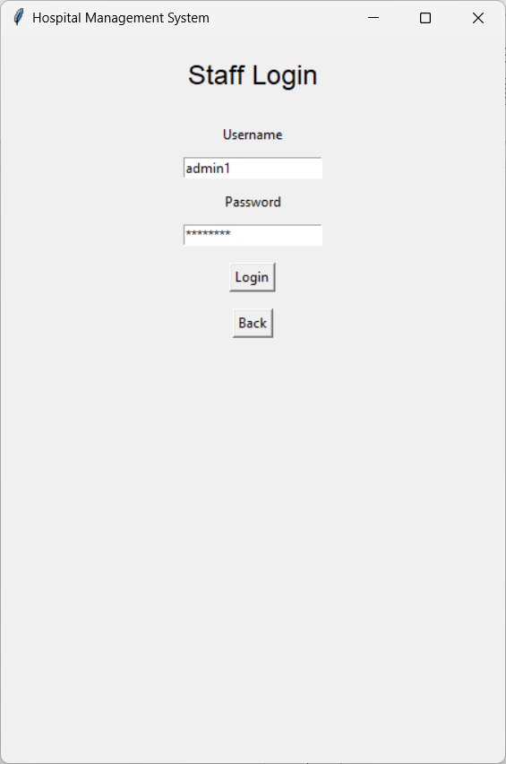**Login Page**
  2. 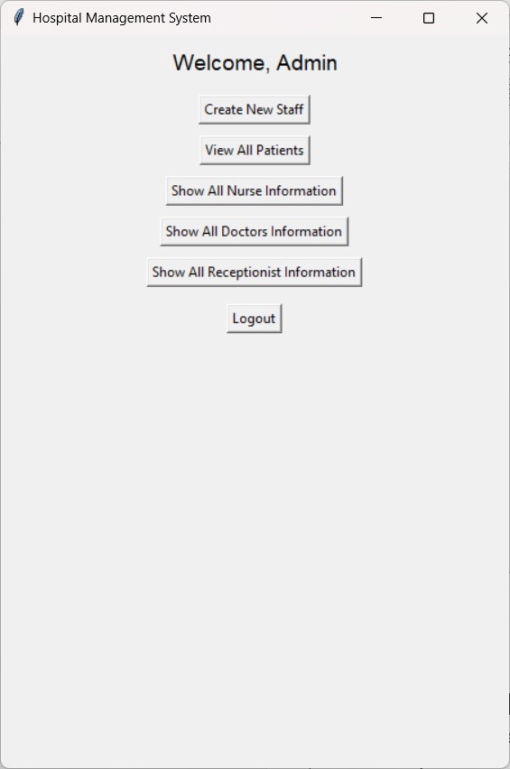**Admin Menu**
  3. **Admin Access**

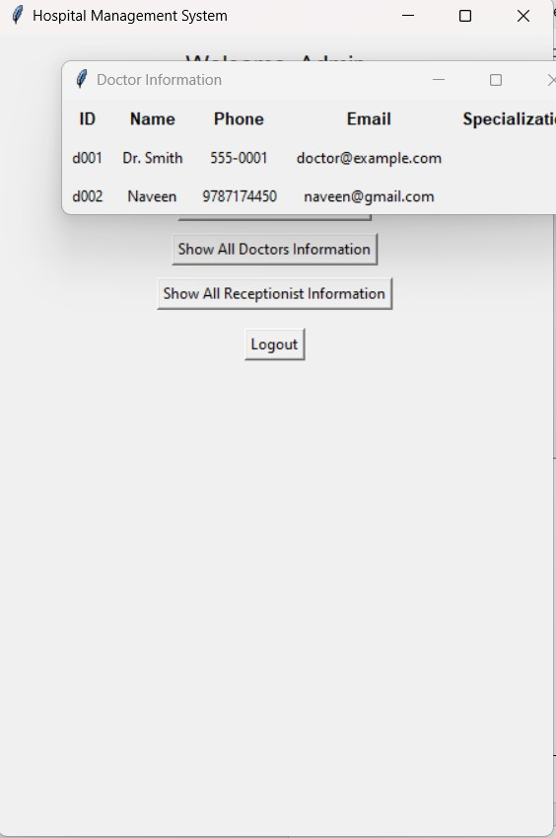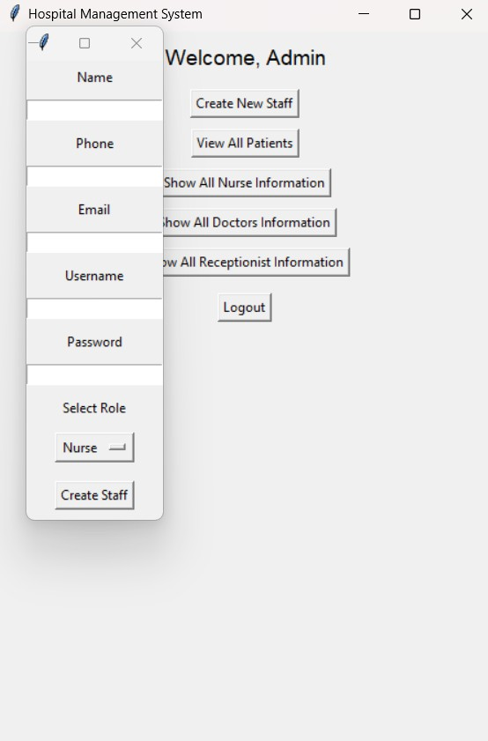

* 1. 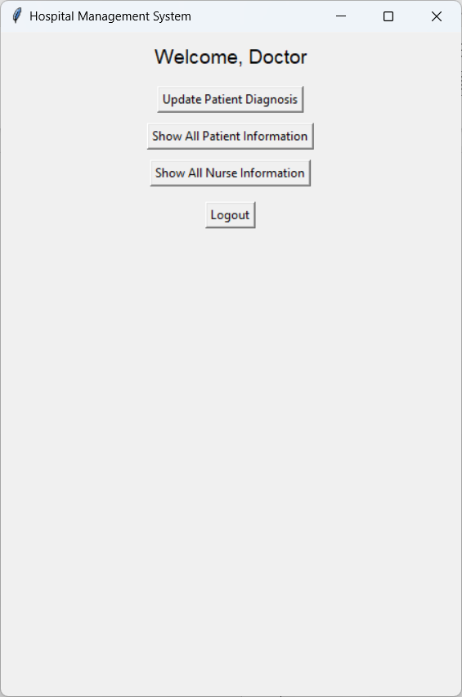**Doctor Menu**

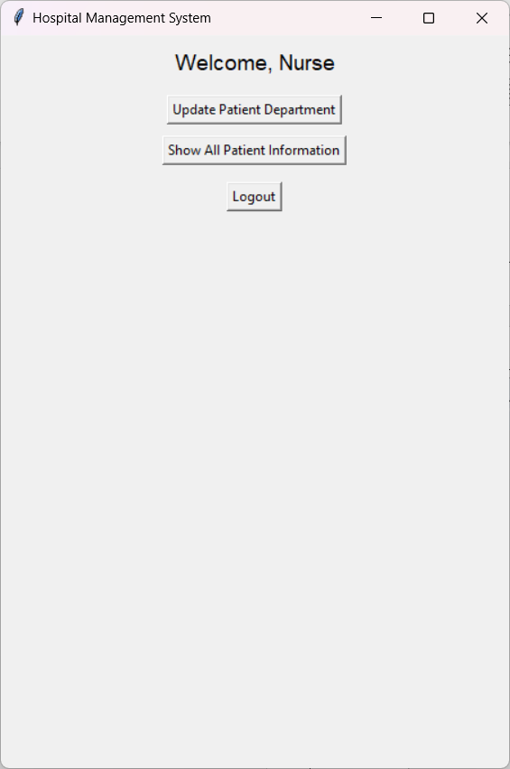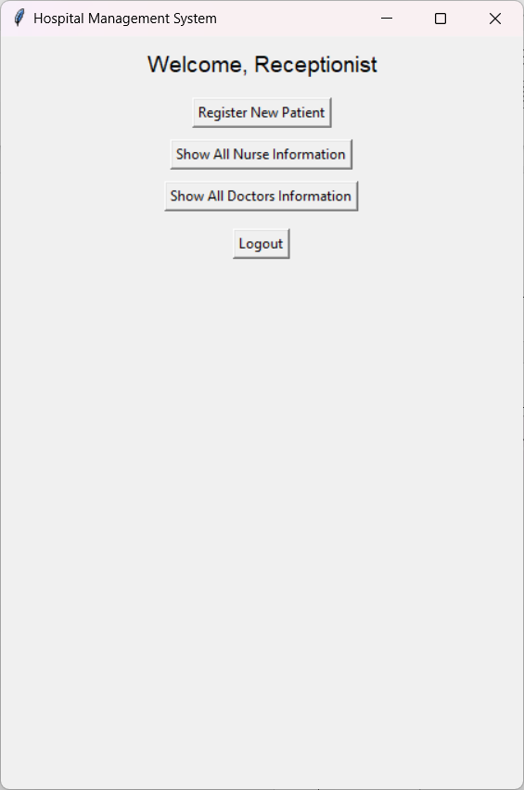

* 1. **Nurse Menu**
  2. **Receptionist Menu**

# CONCLUSION

The implementation of the Hospital Management System (HMS) has profoundly transformed the operational landscape of the healthcare facility, addressing longstanding challenges while introducing a suite of advanced functionalities that enhance service delivery. Throughout this project, we have explored the critical areas of patient management, administrative efficiency, and financial operations, yielding results that affirm the system's value to both healthcare providers and patients.

## Key Findings

1. **Enhanced Operational Efficiency:** The HMS successfully streamlined numerous administrative processes, leading to significant reductions in time and resource expenditure. The automation of tasks such as patient registration, appointment scheduling, and billing has freed up valuable staff time, enabling healthcare providers to focus on patient care rather than paperwork. This shift not only enhances productivity but also fosters a more patient-centered environment.
2. **Improved Patient Care:** The system's ability to consolidate and centralize patient information has greatly enhanced care coordination among healthcare providers. With comprehensive access to medical histories, treatment plans, and test results, clinicians are better equipped to make informed decisions, leading to improved patient outcomes and safety. Additionally, the introduction of a patient portal has empowered patients by giving them access to their health records, fostering greater engagement in their care processes.
3. **Financial Benefits:** The financial impact of the HMS is significant, as evidenced by the reduction in operational costs and an increase in revenue. By minimizing claim rejections and improving billing processes, the hospital has enhanced its financial health. The decrease in administrative overhead further underscores the system's capacity to contribute to a more sustainable financial model in healthcare.
4. **High Patient Satisfaction Rates:** The survey results indicating a marked increase in patient satisfaction highlight the HMS's role in improving the overall patient experience. Patients have reported greater ease in accessing healthcare services, scheduling appointments, and obtaining their medical information, which has led to higher levels of satisfaction and trust in the healthcare system.

## Reflection on Significance

The success of the HMS underscores the transformative potential of technology in healthcare management. In a sector where efficiency, accuracy, and patient engagement are paramount, the adoption of an integrated management system represents a vital step forward. The project not only demonstrates the practical benefits of digital solutions but also emphasizes the importance of continuous adaptation and improvement in response to the evolving needs of healthcare environments.

## Recommendations for Future Development

To build on the successes of the HMS, several recommendations can be made for future enhancements and research:

1. **Ongoing User Training:** Continuous education and support for users should be prioritized to ensure they can fully leverage the system's capabilities. Establishing regular training sessions and creating comprehensive user manuals can help users adapt to system updates and new features more effectively.
2. **Integration with Emerging Technologies:** Future iterations of the HMS should explore integration with emerging technologies such as artificial intelligence (AI) and machine learning (ML). These technologies could enhance predictive analytics capabilities, improving patient care outcomes through data-driven insights.
3. **Expansion of Functionalities:** The HMS could be expanded to include telemedicine features, allowing for remote consultations and follow-ups. This addition would provide greater flexibility for patients, particularly in rural or underserved areas, and contribute to a more inclusive healthcare approach.
4. **Feedback Loop for Continuous Improvement:** Establishing a robust feedback mechanism will be crucial for the ongoing success of the HMS. Regular input from users can drive

iterative improvements, ensuring the system remains aligned with the changing needs of healthcare providers and patients alike.

1. **Research into Broader Applications:** Further research could explore the potential applications of the HMS model in other healthcare settings, such as outpatient facilities, long- term care facilities, and community health organizations. Understanding the adaptability of the system across various contexts can provide insights into its broader impact on healthcare management.

## Final Thoughts

In conclusion, the Hospital Management System has proven to be a critical asset in modernizing healthcare management. Its implementation has led to substantial improvements in operational efficiency, patient care, financial performance, and overall patient satisfaction. As healthcare continues to evolve, the integration of comprehensive management systems like the HMS will be essential in navigating the complexities of delivering high-quality care in an increasingly digital world. The journey of transformation initiated by this project paves the way for a future where healthcare is not only more efficient but also more responsive to the needs of patients and providers alike.